# AWARE CPRS InstallShield Wizard

**NOTE**: We recommend that the local IT staff complete this step. The person executing the installations must have full administrator privileges on the local workstations.

Download the AwareDllInstaller-***xxx***.exe file from the AWARE Subversion site ([https://54.225.241.69/svn/aware/Deployment/AWARE Version 1.1.6](https://54.225.241.69/svn/aware/Deployment/AWARE%20Version%201.1.6) ) to a location on the workstation desktop. Subversion will ask for a username and password for authentication (Figure 1 – Subversion Software Download).

***xxx*** designates the site (CHA for Charleston and LON for Long Beach).

It can also be found on the sites AWARE SQL Server

The Subversion Username is “**awareva**” and the password is “**P@sswd!**”.

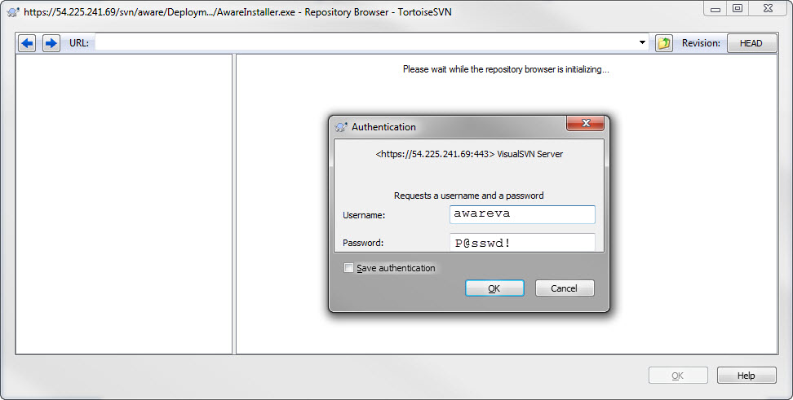

Figure – Subversion Software Download

Validate the properties of the “**AwareDllInstaller-xxx.exe**”. Right click the downloaded “AwareDllInstaller-xxx.exe” file and select “Properties”. Then click the Unblock button, then click OK (Figure 2).

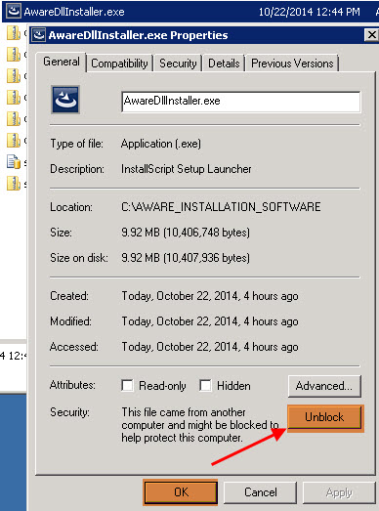

Figure – UnBlock

Right click the downloaded “AwareDllInstaller.exe” file and select “Run as Administrator” (Figure 3).

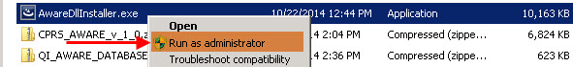

Figure – Run the Aware CPRS Desktop Installer

**Note:** The “**AwareDllInstaller-xxx.exe**” must be Run As Administrator to install correctly.

This starts the Aware InstallShield executable. Click the Next button (Figure 4).

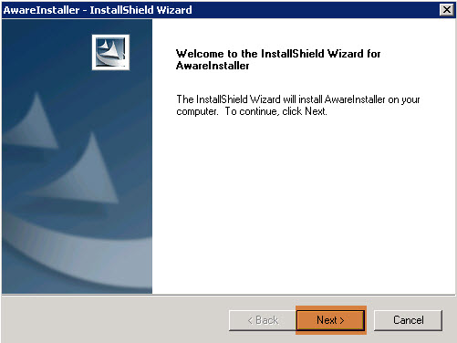

Figure – Aware CPRS Desktop Installer

When prompted, read and accept the terms of the license agreement and click the Next button (Figure 5).

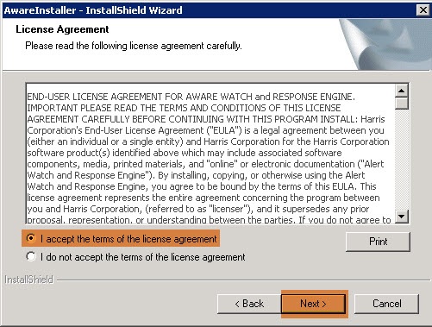

Figure – Accept the Aware License Agreement

Make sure the Install to folder is pointer to C:\Program Files\VistA\AWARECPRS. If not click the Change button and enter the correct path.

Enter the Fully Qualified Domain Name or IP address of the VA Site’s VistA Server in the *VistA Server Address:* field and CPRS Port Number in the *VistA Server Port:* field (Figure 6). Then click the Next button.

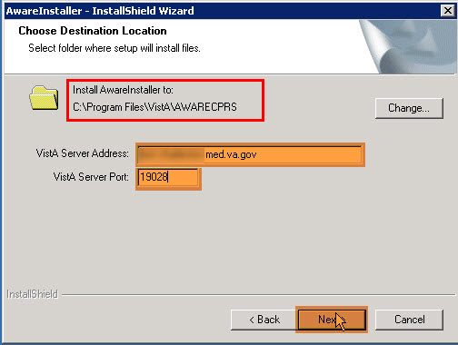

Figure – Enter the sites VistA Server Address and Port Number

Click the Install button to complete the installation (Figure 7).

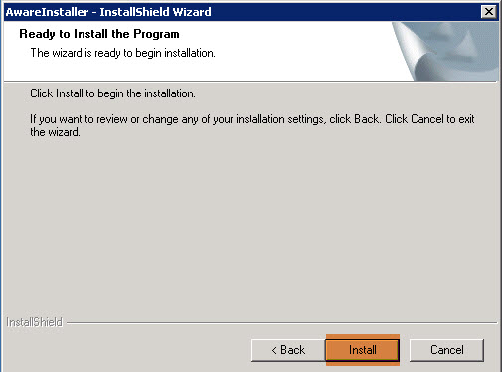

Figure – Complete the Installation

Click the Finish button (Figure 8).

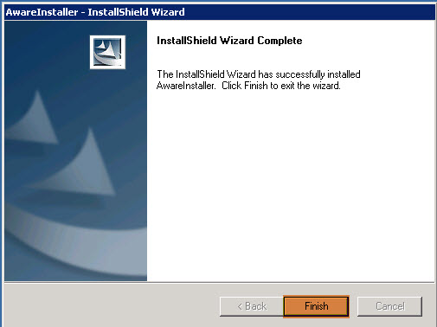

Figure – Finish the Installation

# AWARE CPRS InstallShield Verification

Validate that InstallShield completed correctly. Open Windows Explorer and browse to “C:\Program Files\VistA\AWARECPRS” folder. Check the “AwareDllInstall.log” for any errors. Confirm the following 6 files are in the folder (Figure 9).

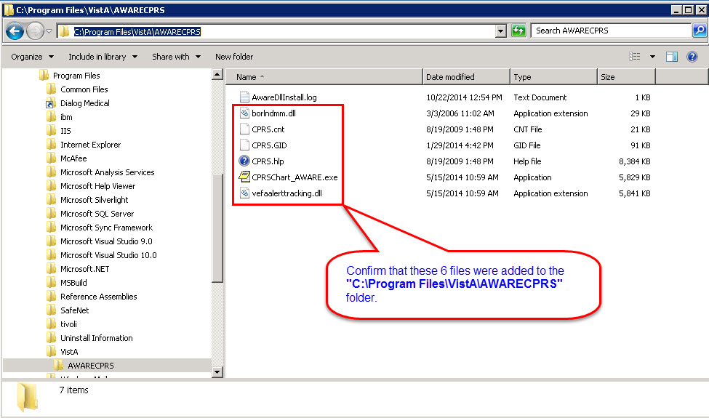

Figure – Validate the Installation